17) Aim: To Design Turing Machine using simulator to accept the input string for odd length of Palindrome over the set {a,b}.

Diagram:

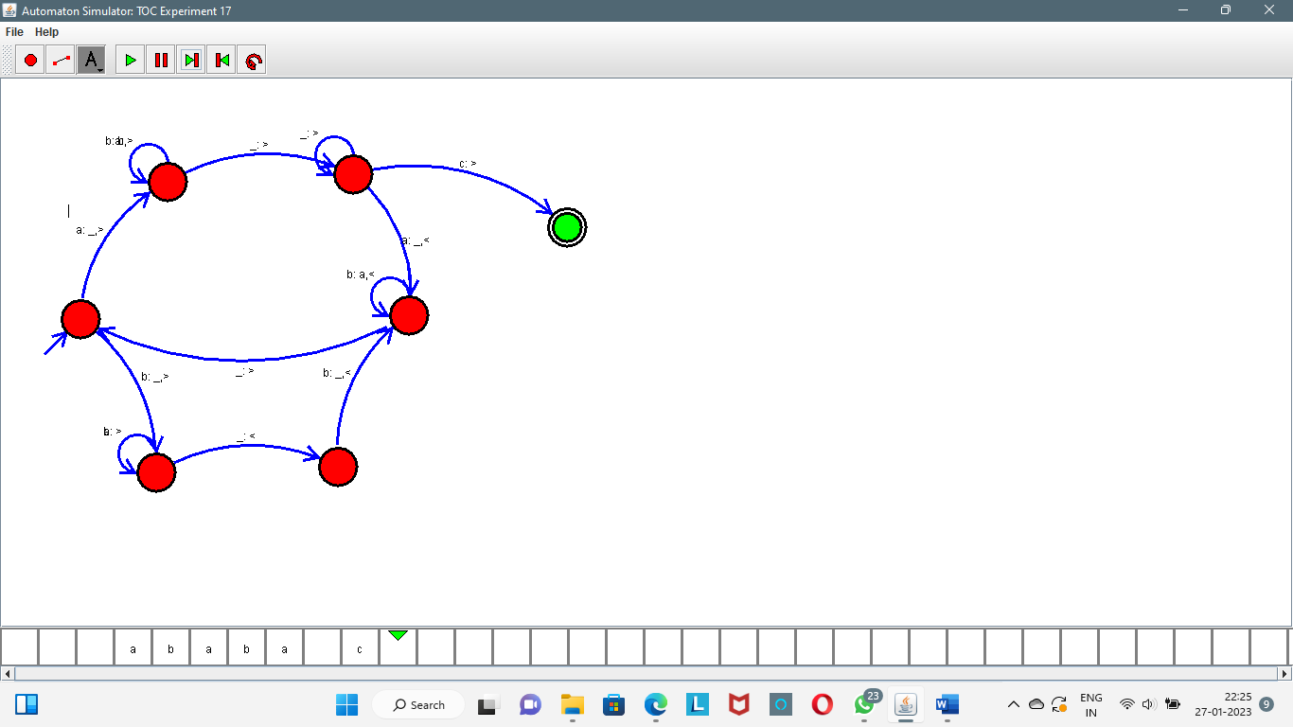

Result:

Successfully executed Turing Machine using simulator to accept the input string for odd length of Palindrome over the set {a,b}.